1. |  |  | Convert the following into symbolic expression and Check whether it is a tautology or not  “The necessary and sufficient condition for the statement ‘If I don’t study, then I fail’ is ‘I study or I fail’ ”
2. |  |  | Brown, Jones and Smith are suspected of a crime. They testify as follows:  Brown: Jones is guilty and Smith is Innocent. Jones: If Brown is guilty then so is Smith  Smith: I am innocent, but at least one of the others is guilty  Check whether all three testimonies are consistent?
3. | (i)  (ii) |  | E(x): x is an earth-like planet, L(x): x supports life.  Give the correct interpretation of the following  - ∀x (L(x) → E(x)) b) ∀x E(x) ∨ ∀x L(x) c) ¬ (∀x (L(x) → E(x)))  Express the symbolic expression of the following sentence “Every person who gets married and has at least a child is called a father”.
4. |  |  | State and prove De Morgan’s Law using Boolean expression.
5. |  | Check the validity of Existence of Superman:  If superman were able and willing to prevent evil, then he would so. If superman were unable to prevent evil, then he would be powerless. If superman were unwilling to prevent evil, then he would be malevolent. Superman doesn’t prevent evil. If superman exists, then he is neither powerless nor malevolent. Therefore, superman doesn’t exist.
6. |  | Use Boolean algebra to simplify the following logic gate circuit:  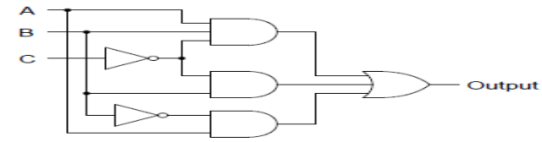  Find the Sum-of-Product and Product-of-Sum canonical forms of the given circuit.
7. | (a)  (b) | Apply the Quine-McKluskey algorithm to minimize the Sum-of-Product of Problem(6)  Let S be the set of all non-negative integers. The relation between any two nonnegative integers, a,b is given that aRb if and only if the remainder of a divided by 8 equals the remainder of b divided by 8. Find whether (S,R) is a Poset or not. |  | [6]  [4]


